DEEPSKILLING – JAVA FSE REACT
PL/SQL Exercises
Name: DARSHAN DONTIBOINA
SUPERSET ID: 8001653

CREATE TABLE Customers (
CustomerID INT PRIMARY KEY,
Name VARCHAR(100),
DOB DATE,
Balance INT,
LastModified DATE
);

CREATE TABLE Accounts (
AccountID INT PRIMARY KEY,
CustomerID INT,
AccountType VARCHAR(20),
Balance INT,
LastModified DATE,
FOREIGN KEY (CustomerID) REFERENCES Customers(CustomerID)
);

CREATE TABLE Transactions (
TransactionID INT PRIMARY KEY,
AccountID INT,
TransactionDate DATE,
Amount INT,
TransactionType VARCHAR(10),
FOREIGN KEY (AccountID) REFERENCES Accounts(AccountID)
);

CREATE TABLE Loans (
LoanID INT PRIMARY KEY,
CustomerID INT,
LoanAmount INT,
InterestRate INT,
StartDate DATE,
EndDate DATE,
FOREIGN KEY (CustomerID) REFERENCES Customers(CustomerID)
);

CREATE TABLE Employees (
EmployeeID INT PRIMARY KEY,
Name VARCHAR(100),
Position VARCHAR(50),
Salary INT,
Department VARCHAR(50),
HireDate DATE
);

ALTER TABLE Customers ADD IsVIP VARCHAR(5);
-- Customers
INSERT INTO Customers VALUES (1,'Amit Sharma',TO_DATE('1985-02-10','YYYY-MM-DD'),1200,SYSDATE,NULL);
INSERT INTO Customers VALUES (2,'Bhavana Reddy',TO_DATE('1990-07-20','YYYY-MM-DD'),1500,SYSDATE,NULL);
INSERT INTO Customers VALUES (3,'Chandan Gupta',TO_DATE('1982-11-02','YYYY-MM-DD'),2000,SYSDATE,NULL);
INSERT INTO Customers VALUES (4,'Deepa Nair',TO_DATE('1978-01-25','YYYY-MM-DD'),2500,SYSDATE,NULL);
INSERT INTO Customers VALUES (5,'Eshan Verma',TO_DATE('1995-09-10','YYYY-MM-DD'),1800,SYSDATE,NULL);

-- Accounts
INSERT INTO Accounts VALUES (1,1,'Savings',1200,SYSDATE);
INSERT INTO Accounts VALUES (2,2,'Checking',1500,SYSDATE);
INSERT INTO Accounts VALUES (3,3,'Savings',2000,SYSDATE);
INSERT INTO Accounts VALUES (4,4,'Checking',2500,SYSDATE);
INSERT INTO Accounts VALUES (5,5,'Savings',1800,SYSDATE);

-- Transactions
INSERT INTO Transactions VALUES (1,1,SYSDATE,500,'Deposit');
INSERT INTO Transactions VALUES (2,2,SYSDATE,300,'Withdrawal');
INSERT INTO Transactions VALUES (3,3,SYSDATE,700,'Deposit');
INSERT INTO Transactions VALUES (4,4,SYSDATE,400,'Withdrawal');
INSERT INTO Transactions VALUES (5,5,SYSDATE,600,'Deposit');

-- Loans
INSERT INTO Loans VALUES (1,1,5000,5,SYSDATE,ADD_MONTHS(SYSDATE,60));
INSERT INTO Loans VALUES (2,2,8000,6,SYSDATE,ADD_MONTHS(SYSDATE,48));
INSERT INTO Loans VALUES (3,3,7500,4,SYSDATE,ADD_MONTHS(SYSDATE,36));
INSERT INTO Loans VALUES (4,4,12000,7,SYSDATE,ADD_MONTHS(SYSDATE,72));
INSERT INTO Loans VALUES (5,5,9000,5,SYSDATE,ADD_MONTHS(SYSDATE,60));

-- Employees
INSERT INTO Employees VALUES (1,'Anita Iyer','Manager',70000,'HR',TO_DATE('2015-06-15','YYYY-MM-DD'));
INSERT INTO Employees VALUES (2,'Bharat Kumar','Developer',60000,'IT',TO_DATE('2017-03-20','YYYY-MM-DD'));
INSERT INTO Employees VALUES (3,'Chitra Menon','Analyst',55000,'Finance',TO_DATE('2018-09-10','YYYY-MM-DD'));
INSERT INTO Employees VALUES (4,'Devendra Singh','Tester',50000,'IT',TO_DATE('2019-12-05','YYYY-MM-DD'));
INSERT INTO Employees VALUES (5,'Esha Patil','HR Specialist',48000,'HR',TO_DATE('2020-07-22','YYYY-MM-DD'));

COMMIT;

-- QUESTION 1
DECLARE
CURSOR cust_cur IS
SELECT CustomerID, DOB
FROM Customers;
v_age NUMBER;
BEGIN
FOR cust_rec IN cust_cur LOOP
v_age := FLOOR(MONTHS_BETWEEN(SYSDATE, cust_rec.DOB) / 12);
IF v_age > 60 THEN
UPDATE Loans
SET InterestRate = InterestRate - 1
WHERE CustomerID = cust_rec.CustomerID;
END IF;
END LOOP;
COMMIT;
END;
/

select * from customers;

-- QUESTION 2
BEGIN
FOR cust_rec IN (
SELECT CustomerID, Balance
FROM Customers
) LOOP

IF cust_rec.Balance > 10000 THEN
UPDATE Customers
SET IsVIP = 'TRUE'
WHERE CustomerID = cust_rec.CustomerID;
ELSE
UPDATE Customers
SET IsVIP = 'FALSE'
WHERE CustomerID = cust_rec.CustomerID;
END IF;

END LOOP;

COMMIT;
END;
/

select * from customers;

-- QUESTION 3
BEGIN
FOR loan_rec IN (
SELECT c.Name,
l.LoanID,
l.EndDate
FROM Customers c
JOIN Loans l
ON c.CustomerID = l.CustomerID
WHERE l.EndDate BETWEEN SYSDATE
AND SYSDATE + 30
) LOOP

DBMS_OUTPUT.PUT_LINE(
'Reminder: Dear ' || loan_rec.Name ||
', Loan ID ' || loan_rec.LoanID ||
' is due on ' || loan_rec.EndDate
);

END LOOP;
END;
/

-- QUESTION 4
CREATE OR REPLACE PROCEDURE SafeTransferFunds(
p_from_account NUMBER,
p_to_account NUMBER,
p_amount NUMBER
)
IS
v_balance NUMBER;
BEGIN
SELECT Balance
INTO v_balance
FROM Accounts
WHERE AccountID = p_from_account;

IF v_balance < p_amount THEN
RAISE_APPLICATION_ERROR(-20001,
'Insufficient Funds');
END IF;

UPDATE Accounts
SET Balance = Balance - p_amount
WHERE AccountID = p_from_account;

UPDATE Accounts
SET Balance = Balance + p_amount
WHERE AccountID = p_to_account;

COMMIT;

EXCEPTION
WHEN OTHERS THEN
ROLLBACK;
DBMS_OUTPUT.PUT_LINE(
'Transfer Failed: ' || SQLERRM
);
END;
/

-- QUESTION 5
CREATE OR REPLACE PROCEDURE UpdateSalary(
p_employee_id NUMBER,
p_percentage NUMBER
)
IS
BEGIN
UPDATE Employees
SET Salary = Salary + (Salary * p_percentage / 100)
WHERE EmployeeID = p_employee_id;

IF SQL%ROWCOUNT = 0 THEN
RAISE NO_DATA_FOUND;
END IF;

COMMIT;

EXCEPTION
WHEN NO_DATA_FOUND THEN
DBMS_OUTPUT.PUT_LINE(
'Employee ID not found.'
);

WHEN OTHERS THEN
DBMS_OUTPUT.PUT_LINE(
'Error: ' || SQLERRM
);
END;
/

-- QUESTION 6
CREATE OR REPLACE PROCEDURE AddNewCustomer(
p_customerid NUMBER,
p_name VARCHAR2,
p_dob DATE,
p_balance NUMBER
)
IS
BEGIN
INSERT INTO Customers
VALUES (
p_customerid,
p_name,
p_dob,
p_balance,
SYSDATE
);

COMMIT;

EXCEPTION
WHEN DUP_VAL_ON_INDEX THEN
DBMS_OUTPUT.PUT_LINE(
'Customer already exists.'
);

WHEN OTHERS THEN
DBMS_OUTPUT.PUT_LINE(
'Error: ' || SQLERRM
);
END;
/

-- QUESTION 7
CREATE OR REPLACE PROCEDURE ProcessMonthlyInterest
IS
BEGIN
UPDATE Accounts
SET Balance = Balance + (Balance * 0.01)
WHERE AccountType = 'Savings';

COMMIT;
END;
/

select * FROM accounts;

-- QUESTION 8
CREATE OR REPLACE PROCEDURE UpdateEmployeeBonus(
p_department VARCHAR2,
p_bonus_percent NUMBER
)
IS
BEGIN
UPDATE Employees
SET Salary = Salary +
(Salary * p_bonus_percent / 100)
WHERE Department = p_department;

COMMIT;
END;
/

select * from employees;

-- QUESTION 9
CREATE OR REPLACE PROCEDURE TransferFunds(
p_from_account NUMBER,
p_to_account NUMBER,
p_amount NUMBER
)
IS
v_balance NUMBER;
BEGIN
SELECT Balance
INTO v_balance
FROM Accounts
WHERE AccountID = p_from_account;

IF v_balance >= p_amount THEN

UPDATE Accounts
SET Balance = Balance - p_amount
WHERE AccountID = p_from_account;

UPDATE Accounts
SET Balance = Balance + p_amount
WHERE AccountID = p_to_account;

COMMIT;

ELSE
DBMS_OUTPUT.PUT_LINE(
'Insufficient balance.'
);
END IF;
END;
/

-- QUESTION 10
CREATE OR REPLACE FUNCTION CalculateAge(
p_dob DATE
)
RETURN NUMBER
IS
BEGIN
RETURN FLOOR(
MONTHS_BETWEEN(SYSDATE, p_dob) / 12
);
END;
/

-- QUESTION 11
CREATE OR REPLACE FUNCTION CalculateMonthlyInstallment(
p_loan_amount NUMBER,
p_interest_rate NUMBER,
p_years NUMBER
)
RETURN NUMBER
IS
v_monthly_rate NUMBER;
v_months NUMBER;
v_emi NUMBER;
BEGIN
v_monthly_rate := p_interest_rate / 12 / 100;
v_months := p_years * 12;

v_emi :=
(p_loan_amount * v_monthly_rate *
POWER(1 + v_monthly_rate, v_months))
/
(POWER(1 + v_monthly_rate, v_months) - 1);

RETURN ROUND(v_emi, 2);
END;
/

-- QUESTION 12
CREATE OR REPLACE FUNCTION HasSufficientBalance(
p_account_id NUMBER,
p_amount NUMBER
)
RETURN BOOLEAN
IS
v_balance NUMBER;
BEGIN
SELECT Balance
INTO v_balance
FROM Accounts
WHERE AccountID = p_account_id;

RETURN v_balance >= p_amount;

EXCEPTION
WHEN NO_DATA_FOUND THEN
RETURN FALSE;
END;
/

-- QUESTION 13
CREATE OR REPLACE TRIGGER UpdateCustomerLastModified
BEFORE UPDATE ON Customers
FOR EACH ROW
BEGIN
:NEW.LastModified := SYSDATE;
END;
/

-- QUESTION 14
CREATE TABLE AuditLog (
AuditID NUMBER GENERATED BY DEFAULT AS IDENTITY,
TransactionID NUMBER,
ActionDate DATE,
ActionType VARCHAR2(50)
);
CREATE OR REPLACE TRIGGER LogTransaction
AFTER INSERT ON Transactions
FOR EACH ROW
BEGIN
INSERT INTO AuditLog(
TransactionID,
ActionDate,
ActionType
)
VALUES(
:NEW.TransactionID,
SYSDATE,
'INSERT'
);
END;
/

-- QUESTION 15
CREATE OR REPLACE TRIGGER CheckTransactionRules
BEFORE INSERT ON Transactions
FOR EACH ROW
DECLARE
v_balance NUMBER;
BEGIN
SELECT Balance
INTO v_balance
FROM Accounts
WHERE AccountID = :NEW.AccountID;

IF :NEW.TransactionType = 'Withdrawal' THEN

IF :NEW.Amount > v_balance THEN
RAISE_APPLICATION_ERROR(
-20002,
'Withdrawal exceeds balance'
);
END IF;

ELSIF :NEW.TransactionType = 'Deposit' THEN

IF :NEW.Amount <= 0 THEN
RAISE_APPLICATION_ERROR(
-20003,
'Deposit must be positive'
);
END IF;

END IF;
END;
/

-- QUESTION 16
DECLARE
CURSOR GenerateMonthlyStatements IS
SELECT AccountID,
TransactionDate,
Amount,
TransactionType
FROM Transactions
WHERE TRUNC(TransactionDate,'MM') =
TRUNC(SYSDATE,'MM');

v_rec GenerateMonthlyStatements%ROWTYPE;
BEGIN
OPEN GenerateMonthlyStatements;

LOOP
FETCH GenerateMonthlyStatements INTO v_rec;
EXIT WHEN GenerateMonthlyStatements%NOTFOUND;

DBMS_OUTPUT.PUT_LINE(
'Account: ' || v_rec.AccountID ||
', Date: ' || v_rec.TransactionDate ||
', Amount: ' || v_rec.Amount ||
', Type: ' || v_rec.TransactionType
);

END LOOP;

CLOSE GenerateMonthlyStatements;
END;
/

-- QUESTION 17
DECLARE
CURSOR ApplyAnnualFee IS
SELECT AccountID
FROM Accounts;

v_fee NUMBER := 100;
BEGIN
FOR acc_rec IN ApplyAnnualFee LOOP

UPDATE Accounts
SET Balance = Balance - v_fee
WHERE AccountID = acc_rec.AccountID;

END LOOP;

COMMIT;
END;
/

-- QUESTION 18
DECLARE
CURSOR UpdateLoanInterestRates IS
SELECT LoanID,
InterestRate
FROM Loans;

BEGIN
FOR loan_rec IN UpdateLoanInterestRates LOOP

UPDATE Loans
SET InterestRate = loan_rec.InterestRate + 0.5
WHERE LoanID = loan_rec.LoanID;

END LOOP;

COMMIT;
END;
/

-- QUESTION 19
CREATE OR REPLACE PACKAGE CustomerManagement AS

PROCEDURE AddCustomer(
p_customerid NUMBER,
p_name VARCHAR2,
p_dob DATE,
p_balance NUMBER
);

PROCEDURE UpdateCustomer(
p_customerid NUMBER,
p_name VARCHAR2
);

FUNCTION GetCustomerBalance(
p_customerid NUMBER
) RETURN NUMBER;

END CustomerManagement;
/

-- QUESTION 20
CREATE OR REPLACE PACKAGE BODY CustomerManagement AS

PROCEDURE AddCustomer(
p_customerid NUMBER,
p_name VARCHAR2,
p_dob DATE,
p_balance NUMBER
) IS
BEGIN
INSERT INTO Customers
VALUES(
p_customerid,
p_name,
p_dob,
p_balance,
SYSDATE
);
END;

PROCEDURE UpdateCustomer(
p_customerid NUMBER,
p_name VARCHAR2
) IS
BEGIN
UPDATE Customers
SET Name = p_name
WHERE CustomerID = p_customerid;
END;

FUNCTION GetCustomerBalance(
p_customerid NUMBER
) RETURN NUMBER
IS
v_balance NUMBER;
BEGIN
SELECT Balance
INTO v_balance
FROM Customers
WHERE CustomerID = p_customerid;

RETURN v_balance;
END;

END CustomerManagement;
/

-- QUESTION 21
CREATE OR REPLACE PACKAGE EmployeeManagement AS

PROCEDURE HireEmployee(
p_id NUMBER,
p_name VARCHAR2,
p_position VARCHAR2,
p_salary NUMBER,
p_department VARCHAR2
);

PROCEDURE UpdateEmployee(
p_id NUMBER,
p_salary NUMBER
);

FUNCTION AnnualSalary(
p_id NUMBER
) RETURN NUMBER;

END EmployeeManagement;
/

-- QUESTION 22
CREATE OR REPLACE PACKAGE BODY EmployeeManagement AS

PROCEDURE HireEmployee(
p_id NUMBER,
p_name VARCHAR2,
p_position VARCHAR2,
p_salary NUMBER,
p_department VARCHAR2
) IS
BEGIN
INSERT INTO Employees
VALUES(
p_id,
p_name,
p_position,
p_salary,
p_department,
SYSDATE
);
END;

PROCEDURE UpdateEmployee(
p_id NUMBER,
p_salary NUMBER
) IS
BEGIN
UPDATE Employees
SET Salary = p_salary
WHERE EmployeeID = p_id;
END;

FUNCTION AnnualSalary(
p_id NUMBER
) RETURN NUMBER
IS
v_salary NUMBER;
BEGIN
SELECT Salary
INTO v_salary
FROM Employees
WHERE EmployeeID = p_id;

RETURN v_salary * 12;
END;

END EmployeeManagement;
/

-- QUESTION 23
CREATE OR REPLACE PACKAGE EmployeeManagement AS

PROCEDURE HireEmployee(
p_id NUMBER,
p_name VARCHAR2,
p_position VARCHAR2,
p_salary NUMBER,
p_department VARCHAR2
);

PROCEDURE UpdateEmployee(
p_id NUMBER,
p_salary NUMBER
);

FUNCTION AnnualSalary(
p_id NUMBER
) RETURN NUMBER;

END EmployeeManagement;
/
CREATE OR REPLACE PACKAGE BODY EmployeeManagement AS

PROCEDURE HireEmployee(
p_id NUMBER,
p_name VARCHAR2,
p_position VARCHAR2,
p_salary NUMBER,
p_department VARCHAR2
) IS
BEGIN
INSERT INTO Employees
VALUES(
p_id,
p_name,
p_position,
p_salary,
p_department,
SYSDATE
);
END;

PROCEDURE UpdateEmployee(
p_id NUMBER,
p_salary NUMBER
) IS
BEGIN
UPDATE Employees
SET Salary = p_salary
WHERE EmployeeID = p_id;
END;

FUNCTION AnnualSalary(
p_id NUMBER
) RETURN NUMBER
IS
v_salary NUMBER;
BEGIN
SELECT Salary
INTO v_salary
FROM Employees
WHERE EmployeeID = p_id;

RETURN v_salary * 12;
END;

END EmployeeManagement;
/

-- QUESTION 24
CREATE OR REPLACE PACKAGE AccountOperations AS

PROCEDURE OpenAccount(
p_accountid NUMBER,
p_customerid NUMBER,
p_type VARCHAR2,
p_balance NUMBER
);

PROCEDURE CloseAccount(
p_accountid NUMBER
);

FUNCTION GetTotalBalance(
p_customerid NUMBER
) RETURN NUMBER;

END AccountOperations;
/
CREATE OR REPLACE PACKAGE BODY AccountOperations AS

PROCEDURE OpenAccount(
p_accountid NUMBER,
p_customerid NUMBER,
p_type VARCHAR2,
p_balance NUMBER
) IS
BEGIN
INSERT INTO Accounts
VALUES(
p_accountid,
p_customerid,
p_type,
p_balance,
SYSDATE
);
END;

PROCEDURE CloseAccount(
p_accountid NUMBER
) IS
BEGIN
DELETE FROM Accounts
WHERE AccountID = p_accountid;
END;

FUNCTION GetTotalBalance(
p_customerid NUMBER
) RETURN NUMBER
IS
v_total NUMBER;
BEGIN
SELECT SUM(Balance)
INTO v_total
FROM Accounts
WHERE CustomerID = p_customerid;

RETURN NVL(v_total,0);
END;

END AccountOperations;
/

OUTPUTS:
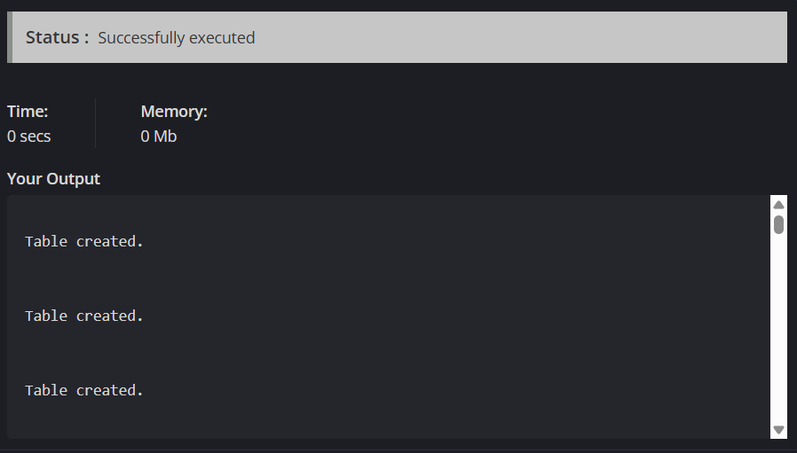
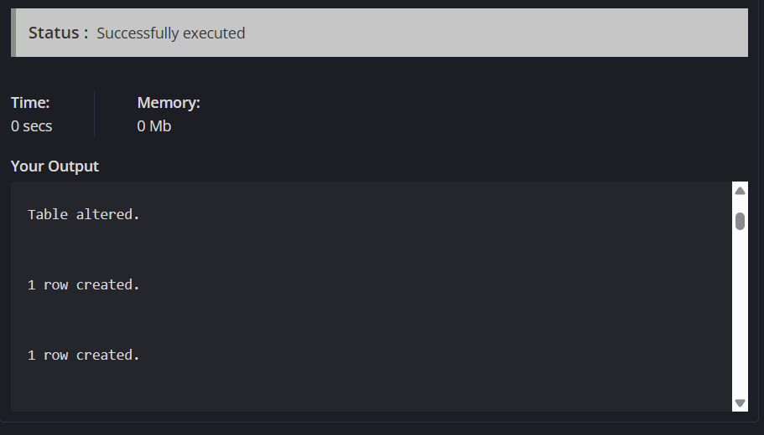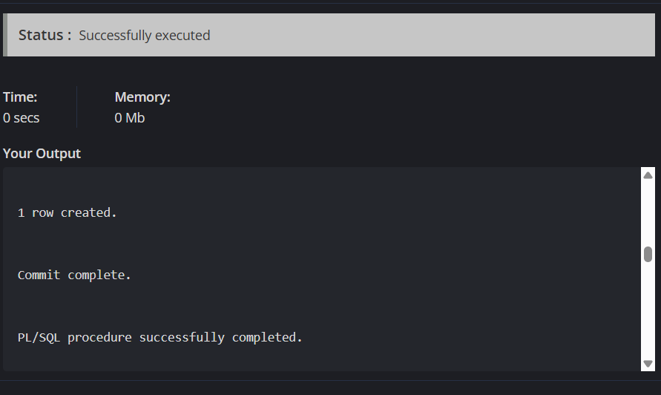
OTHER OUTPUTS:

Table created.

Table created.

Table created.

Table created.

Table created.

Table altered.

1 row created.

1 row created.

1 row created.

1 row created.

1 row created.

1 row created.

1 row created.

1 row created.

1 row created.

1 row created.

1 row created.

1 row created.

1 row created.

1 row created.

1 row created.

1 row created.

1 row created.

1 row created.

1 row created.

1 row created.

1 row created.

1 row created.

1 row created.

1 row created.

1 row created.

Commit complete.

PL/SQL procedure successfully completed.

CUSTOMERID
----------
NAME
--------------------------------------------------------------------------------
DOB BALANCE LASTMODIF ISVIP
--------- ---------- --------- -----
1
Amit Sharma
10-FEB-85 1200 19-JUN-26

2
Bhavana Reddy
20-JUL-90 1500 19-JUN-26

CUSTOMERID
----------
NAME
--------------------------------------------------------------------------------
DOB BALANCE LASTMODIF ISVIP
--------- ---------- --------- -----

3
Chandan Gupta
02-NOV-82 2000 19-JUN-26

4
Deepa Nair

CUSTOMERID
----------
NAME
--------------------------------------------------------------------------------
DOB BALANCE LASTMODIF ISVIP
--------- ---------- --------- -----
25-JAN-78 2500 19-JUN-26

5
Eshan Verma
10-SEP-95 1800 19-JUN-26

PL/SQL procedure successfully completed.

CUSTOMERID
----------
NAME
--------------------------------------------------------------------------------
DOB BALANCE LASTMODIF ISVIP
--------- ---------- --------- -----
1
Amit Sharma
10-FEB-85 1200 19-JUN-26 FALSE

2
Bhavana Reddy
20-JUL-90 1500 19-JUN-26 FALSE

CUSTOMERID
----------
NAME
--------------------------------------------------------------------------------
DOB BALANCE LASTMODIF ISVIP
--------- ---------- --------- -----

3
Chandan Gupta
02-NOV-82 2000 19-JUN-26 FALSE

4
Deepa Nair

CUSTOMERID
----------
NAME
--------------------------------------------------------------------------------
DOB BALANCE LASTMODIF ISVIP
--------- ---------- --------- -----
25-JAN-78 2500 19-JUN-26 FALSE

5
Eshan Verma
10-SEP-95 1800 19-JUN-26 FALSE

PL/SQL procedure successfully completed.

Procedure created.

Procedure created.

Warning: Procedure created with compilation errors.

Procedure created.

ACCOUNTID CUSTOMERID ACCOUNTTYPE BALANCE LASTMODIF
---------- ---------- -------------------- ---------- ---------
1 1 Savings 1200 19-JUN-26
2 2 Checking 1500 19-JUN-26
3 3 Savings 2000 19-JUN-26
4 4 Checking 2500 19-JUN-26
5 5 Savings 1800 19-JUN-26

Procedure created.

EMPLOYEEID
----------
NAME
--------------------------------------------------------------------------------
POSITION SALARY
-------------------------------------------------- ----------
DEPARTMENT HIREDATE
-------------------------------------------------- ---------
1
Anita Iyer
Manager 70000
HR 15-JUN-15

EM...

